CRM Project

Functional Specification - Enhancement

CRM.PP6.CM-090-090-220-E_FACTA Compliance
FO_ENH_3860

Deliverable Name | FO_ENH_3860
Date | 11/0/2010
Revision | V1.0
Signed off By | Functional lead/PP6 Owner
Signoff Date

TABLE OF CONTENTS

1. Version 3
2. Approvals 3
3. Priority Mention the Priority of the object from the FRICEW list in ILM. Processing Mode (check all that apply) 3
Low Medium High 3
4. Enhancement Requirements Description 4
5. Impacted Systems 8
6. Approach to be followed < List the type of enhancement whether it is a user exit, BADI or Custom transaction> 8
7. Roles and Volumes 8
8. Security & Control Requirements 9
8.1 Security Requirements 9
8.2 Control/Audit Requirements 9
9. Dependencies 10
9.1 Development Dependencies 10
9.2 Run/Execution Dependencies 10
9.3 Archiving Dependencies 10
10. Execution Steps 10
10.1 Process Description 10
10.2 Process Flow 11
10.3 As-Is Systems Referred To 13
10.4 Processing Options 13
11. Enhancement Description 14
11.1 Detailed Description of the Enhancement 14
11.2 UI Design and Screen Flow < Mention the WEBUI Design in the sense the mock up screens and the navigation flow between the screens etc> 19
11.3 Access Method or Path for Enhancement 19
11.4 Required Custom Tables (if known) 19
11.5 Error Handling Rules 19
12. Enhancement Reconciliation & Testing Requirements 21
12.1 Data Validation 21
12.2 Testing Reconciliation 21
12.3 Performance Issues 21
13. Additional Information 21
14. Open Items 21
15. Functional Unit Test cases <Here they should list the possible test scenarios in the table below> 22

Version
Ensure that any approved change requests that affect scope are documented in the revision history and include CR #.
Version | Change Description | Author | Date Released | Sections Impacted
Enter in the version number | Brief description of the change | Who made the change | Date change was made | Mention the sections impacted with this change
1.0 | Document Creation | Ronda Clandening | 11/03/2010
2.0 | Changed mapping for addresses in section 11.1 | Ronda Clandening | 3/2/2011 | Section 11.1
3.0 | Changed section 4 – DQM Address Validation and What Address is Sent to Equifax. Added new screen shot | Ronda Clandening | 3/24/2011 | Section 4  Section 11.1
3.1 | Final Review with the Business on address validation | Ronda Clandening | 3/29/2011 | Section 4
4. | Updates per Dev | Ronda Clandening | 4/5/2011 | Section 4 New Service Request and Section 11.1 – Updated tables for #1, 2, and 3
5 | Updates per feedback from DEV | Ronda Clandening | 4/7/2011 | Section 4 New Service Request, Section 11.1 (section 1,2,3 – made mention of a spinning wheel displayed to user while validation runs)
6 | Updates per feedback from DEV | Ronda Clandening | 4/15/2011 | Pg 7, changed creation date to changed date on ZFAC/IDF. Removed SO_ENH_010 from Section 9.1

Approvals
The individuals listed below will be required to review and approve this document.
Reviewers Title | Reviewer Role | Name
Project Title of Reviewer | Reviewer's Role (Responsible, Approve, Consult, Inform) | Reviewer's Name
Technical Team Lead | Approve | V. Krishna Karunakaram
CRM Functional Team Lead | Approve | Robert Smeltekop
Business Owner | Approve | Brent Meschke
Business Owner | Approve | Anita Jackson
Business Owner | Approve | Diane Couture
Business Owner | Approve | Corey Williams
Business Owner | Approve | Helen Rusk

Priority
Mention the Priority of the object from the FRICEW list in ILM.
Processing Mode (check all that apply)

Low Medium High
N/A

Enhancement Requirements Description
<This section should contain a detailed description of the business requirements for this enhancement in business terms. Please insert any description of the business flow which would aid in understanding this process.>

A new FACTA Validation View is needed to meet the business requirements.

Business Partner Validation (FACTA)

Business Partner Validation (FACTA) – To be in compliance with state and federal regulations under the Fair and Accurate Credit Transactions Act (FACTA), Consumers Energy is required to provide an identification validation process by May 1, 2009.

When is FACTA Validation Required?

Business Partner Validation (FACTA) – Before FACTA validation will occur, a check is done on a Business Partner to see if their role is that of a “Contract Partner”, and the type of “Person”. Validation will NOT occur if both requirements are not met on the Business Partner, or for any other Business Partner roles or types

In order to be in compliance with FACTA, identity validation will take place during the following processes for residential accounts: (1) CRM New Contract process as per business role, (2) New Service Request process as per business role, and (3) Business Partner Change process as per business role.
See details below for each specific process.

What Occurs during FACTA Validation?

The customer is asked to provide 4 pieces of identification, (1) Social Security (optional) and/or (2) Michigan Driver’s License number (optional), (3) previous/current physical address (required), and (4) date of birth (optional). If the customer is unable or unwilling to provide the ID necessary to perform validation or the FACTA Validation fails, the customer will be asked to provide positive ID prior to the completion of their request for service (a model statement is presented to the user in the summary of the New Contract and a pop up during the New Service Request process if FACTA Validation fails. If FACTA Validation fails during the New Service Request the user is unable to continue with the New Service Request and is returned to the Order Management view.

How the 4 pieces of identification are gathered for each process will be described in detail in the individual processes below.

Previous entries made to the social security and driver’s license field will be masked.
Refer to PP6 CM-090-090-055-E.MD_ENH_010 Sensitive Data Masking for BP for details.

New Contract Process

FACTA validation will be applied to all business roles (mandatory for the CSR 2, CSR 3, and CSR 4) during the New Contract process and optional for non-CSR roles.

Non-CSR business roles may decline FACTA validation by providing a reason via the ‘Skip Validation’ dropdown during the New Contract process. The system will not allow the user to continue unless validation is performed, or a ‘Skip Validation’ reason is provided. The CSR role will not have the ‘Skip Validation’ button displayed (hidden or grayed out).

Skip Validation options will be:

- Back Office
- Business Center
- CES Group
- Consumer Affairs
- Credit Batchers
- Credit Schedulers
- Customer Billing
- Damage Claims
- Device Mgmt Inbox Team
- Fraud Dept
- ROC – Schedulers
- Theft Dept
- UA/DA – Royal Oak
- VCC Management

During the New Contract process if the BP does not have the role of “Contract Partner” and type of “Person” the FACTA Validation View will be grayed out.

If a successful validation is ran, the Validate button will be disabled.

During the New Contract process any changes made during FACTA Validation will be saved to the BP when the user selects Submit Process.

New Service (New Construction) Request Process

FACTA validation will be applied to all business roles (mandatory for all business roles). Skip Validation button will be disabled. If applicable the FACTA Validation View will be presented as a pop up during the New Service Request process.

There will be two instances when a non-CSR role will not go through FACTA Validation during the New Service Request process.
- If the BP already has a ZFAC/IDF contact which has been closed and a 2nd FACTA Validation occurs within 5 days of the changed date for the IDF Contact change (meaning the original IDF contact has been closed), then the non-CSR role will go automatically to the New Service Request process. If the 5 day/closed contact change does not exist, then the FACTA Validation is mandatory for the non-CSR role. The Customer Info field will be 02 (closed)
- If the BP already has a ZFAC/IDP Contact and 2nd FACTA Validation occurs within 5 days of the ZFAC/IDP Contact creation date, then the non-CSR role will go automatically to the New Service Request process. If the ZFAC/IDP Contact does not exist, then the FACTA Validation is mandatory for the non-CSR role. The Customer Info field will be 02 (closed)

During the New Service Request process when FACTA Validation is performed, any changes made will be saved to the BP.

Change Business Partner Process

The CSR 2, 3, and 4 business roles will NOT be prompted with FACTA validation during the Change Business Partner process.

FACTA validation will be applied to non-CSR business roles during the Change Business Partner process.

Non-CSR business roles may decline FACTA validation by providing a reason via the ‘Skip Validation’ dropdown during the Change Business Partner process. The system will not allow the user to continue unless validation is performed, or a ‘Skip Validation’ reason is provided.

Skip Validation options will be:

- Back Office
- Business Center
- CES Group
- Consumer Affairs
- Credit Batchers
- Credit Schedulers
- Customer Billing
- Damage Claims
- Device Mgmt Inbox Team
- Fraud Dept
- ROC – Schedulers
- Theft Dept
- UA/DA – Royal Oak
- VCC Management

FACTA will be launched upon SAVE during the Change Business Partner process if changes have been made to any of the following fields:

- Name
- Date of Birth
- Social Security Number
- Michigan Driver’s License
- Michigan State Issued Photo ID
- Passport
- US Military ID
- Native American Tribal ID

If no changes were made to the above fields, FACTA will NOT launch. The date of birth field will not be a required field. If the user does not enter a date of birth, they will be prompted with a message indicating the date of birth is missing.

If any changes that are made to the BP during FACTA Validation save the changes to the BP.

Changes for CRM 7.0

- A change will need to be made on how the connection to the FACTA interface will be triggered from CRM 7.0.

- During Change Business Partner process, FACTA validation will be launched upon SAVE. Logic will have to be built to check if changes were made to any of the following fields:

- Name
- Date of Birth
- Social Security Number
- Michigan Driver’s License
- Michigan State Issued Photo ID
- Passport
- US Military ID
- Native American Tribal ID

If no changes were made to the above fields, FACTA validation will NOT launch.

DQM Address Validation and What Address Information is sent to Equifax?

Equifax requires that the current address be sent in the interface. Equifax treats current and former addresses the same with respect to address verification. Address verification will not fail if the first address can't be verified. It checks all addresses that were sent in as part of the input before saying if it was verified or not.

Addresses will be described as follows: Current Address fields represent what is displayed on the FACTA Validation view. Current Address may be derived by the system or entered by the user. Former Address will always be derived by the system if applicable.

Address information will be sent to Equifax during the following processes: New Contract Process, New Service (New Construction) Request Process, and Change Business Partner Process. DQM validation will occur only if a user enters an address at the Current Address field on the FACTA Validation view. The addresses sent to Equifax will be determined in the following way:

- If Business Partner (BP) has never had an active premise (e.g. BP created for move-in), then prompt the user to enter the BP’s current address at the Current Address field on the FACTA Validation view, and send that address as Current Address.
- If the BP has 1 active premise, send that address as Current Address (pre-populate the address at the Current Address field and make the Current Address fields un-editable). If this same BP has 1 or more inactive premises, then send the most recent inactive premise address as Former Address.
- If the BP has 2 or more active premises then the system will determine the active premise based on consumption (largest consumption premise will be the selected premise, based on 12 months history) on the FACTA Validation view. If this same BP has 1 or more inactive premises, then send the most recent inactive premise address as Former Address.
- If the BP has 1 or more inactive premises and no active premise, then prompt the user to enter the BP’s current address at the Current Address field on the FACTA Validation view, and send that address as Current Address, and send the most recent inactive premise address as Former Address.
- The Current Address and Former Address will be added to the text line of the FACTA contact created.

Impacted Systems
<This list should include systems that are being impacted as a result of this enhancement.>

CRM 7.0 Web IC : CRM 7.0 Web Client Interaction Center Production System
ECC 6.0 / IS-U ECC 6.0 / IS-U : Back End Production System (Enterprise Central Component)

Approach to be followed
< List the type of enhancement whether it is a user exit, BADI or Custom transaction>
Total custom development of the FACTA view is required.

Roles and Volumes
<Describe information regarding users and volumes. Make sure to note if the use of this development will require additional communication and/or training. Also, specify what the volume requirements will be needed by the Go-Live date.

Complete the table below with the correct project-specific information for this functional specification. Instructions are in the middle row, and a sample entry is in the bottom row.>

Role | Estimated Volume Requirement | Comments
List name of role; should come from the list of security roles | Enter the estimated volume requirements that will be needed by the Go-Live date | Enter other comments including if this development will require additional communication and/or training
CSR 2, CSR 3, CSR 4, VCC MGMT | +- 600 times per day | Per Business Role
BCOS | +-5 times per day | Per Agent
Billing | +- 5 times per day | Per Agent
Consumer Affairs | +- 15 times per day | Per Agent
Revenue Recovery | +- 15 times per day | Per Agent
Gas Trans | **times per day | Per Agent

Security & Control Requirements

Security Requirements
<Describe any security requirements that need to be put in place as a result of this development object. This could include security access to affected transactions or new transactions that may result from this development. If the enhancement has to be archive enabled, list additional security to be added to the roles.>
This enhancement will be available to the following business roles:

CSR 2
CSR 3
CSR 4
VCC MGMT
BCOS
Billing
Consumer Affairs
Revenue Recovery
Gas Trans

Control/Audit Requirements
<Describe any control requirements that need to be put in place as a result of this development object>.
- If applicable, please answer the question and also provide detail to the question.
- The questions listed below are not all inclusive to the control requirement that may be required. If there are any other controls requirements please document them as well.

- Indicate if this enhancement is being developed to address a control requirement?
- Financial/SOX Impact - Does the enhancement have any impact to financial reporting? If yes, is the amount significant (i.e. greater than $35 million annually)? Please provide an estimate.
- Regulatory Impact - Does the enhancement have any impact to regulatory compliance (i.e. FERC, NERC, etc)? If yes, please provide a reference to the rule and describe the impact.
CRM Control ID 100 - Contract Management - Create/Change New Contract (Move In) - Invalid ("fake") customers are created in the system.

CRM is customized to include a FACTA validation by CSR's as part of the New Contract process (Move-In process), New Service Request process, and Change Business Partner process. The following information is required when running FACTA Validation:
- Social Security and/or Driver’s License must be provided
- Michigan Driver’s License must be 13 characters in length and the first character must be a letter. MI and US are defaulted by the system
- Social security number must be 9 character in length
- Other forms of ID such as State and Out-of-state ID’s are accepted, but not validated.
- Date of birth
- Previous premise address
NOTE: This also includes Condition of Service Contracts (COS). Only valid roles should have access to Condition of Service contracts.
The following fields however can be maintained by agents: Passport, State ID MI, State ID Other, Tribal ID.
If identity cannot be proved then the customer has 14 days to present a valid form of ID to prove identity.
Non CSR agents will be allowed to decline FACTA validation, but must provide a reason via the dropdown list.

- Operational Impact - Is the enhancement relied upon for a mission critical process or providing services to customers? If yes, please identify the mission critical process and describe how this enhancement is used in the context of this process.

Dependencies

Development Dependencies
<List the configuration, development, and other work that must be considered during the creation of this enhancement.>

CRM.PP6.CM-150-020-02_E.MD_ENH_010-BP Search Sensitive Data
CRM.PP6.CM-090-150-240-I.CM_ENH_270-DQXI Address Validation 1.2

Run/Execution Dependencies
<Once in production, this development object may need to be executed before or after another system event. List other system events that this development object should follow or precede. If the enhancement is to be archived enabled, does it need to have adequate archived sessions, info structures, etc established in order to test/execute.>

Not Applicable. Once this development is complete all other process steps created for Create New Contract will become dependent on this development.

Archiving Dependencies
<List how the changes would impact archiving, if the enhancement impacts existing archived objects (i.e. table structures). Also list what needs to be regression tested from an archiving perspective.>

N/A

Execution Steps

Process Description
<Explain the process for when this development object will be used. If this is tied back to a certain task within a process you may insert the Task Profile document here as well.

Enter any of the following information available:
- Transaction Code
- User Exits
- Performance Consideration
- Z Tables created
- Code reuse.
FACTA Validation will take place during the following processes:

- New Contract process
- New Service Request process
- Business Partner Change process (if select fields are changed, see section 4 for details)

Process Flow
<Create a diagram that visually depicts the process.>

FACTA Validation during New Contract process:
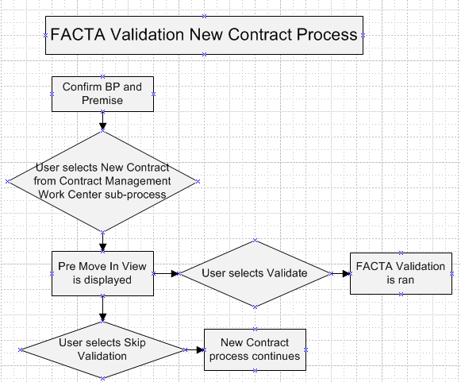

FACTA Validation during New Service Request process:

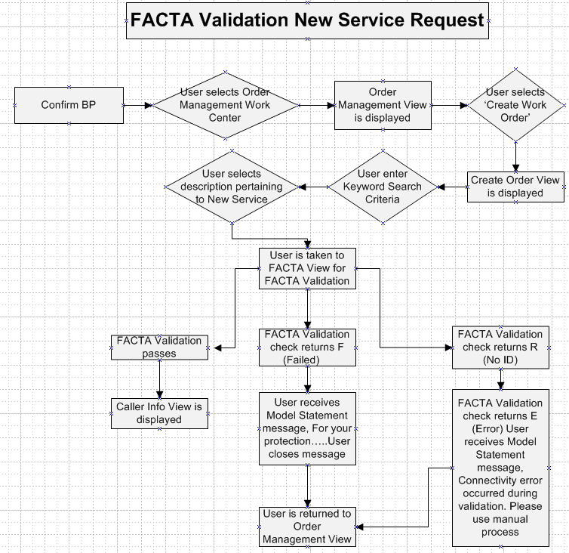

FACTA Validation during Change Business Partner:

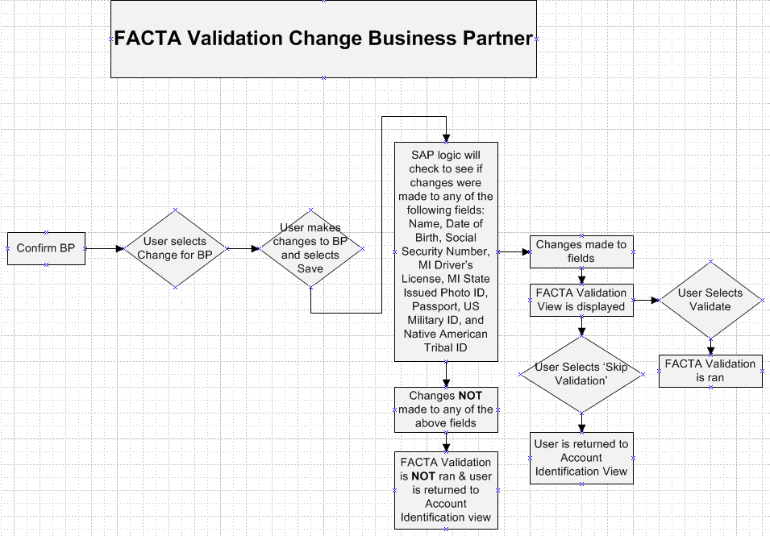

As-Is Systems Referred To
<List the systems that the task pertaining to this development object is performed in. If this is a new task (i.e. not being performed today), list it ‘Not applicable’.>
CRM 5.0 Win IC : Win Client Interaction Center - Production System
ECC 6.0 / IS-U ECC 6.0 / IS-U : Back End Production System (Enterprise Central Component)

Processing Options
<Indicate the Processing Mode, Frequency, and Lifetime of Development by selecting and placing an ‘X’ in the box next to the correct options below. Right click on the gray box, select properties, and specify “Checked”.>
Processing Mode (Select one of the following)
Batch Online – via Transaction Code Online – via Menu Path
On demand

Frequency (Select one of the following)
Daily
Weekly Quarterly
Monthly Annually
Other (If other, describe here)

Lifetime of Development (select one)
Permanent
Temporary, e.g. until rollouts are complete, specify details here

Enhancement Description
<Provide a brief description of the enhancement.>

In order to meet FACTA requirements we require 2 new FACTA views. These views will be used in the following processes as required by business role: New Contract process, New Service Request process, and the Change Business Partner process.

Detailed Description of the Enhancement
<Provide a written description of the functionality that needs to be developed. Identify/describe the SAP application transaction that uses or is used to invoke the enhancement. Describe tables, transactions, reports, forms, screens and other objects that need to be created or modified. Insert a Visio flow diagram of the process to be executed by the enhancement, and add any other information required to develop the enhancement.>

In order to be in compliance with FACTA, identity validation will take place during the following processes for residential accounts: (1) CRM New Contract process as per business role, (2) New Service Request process as per business role, and (3) Business Partner Change process as per business role.
See details below for each specific process.

Business Partner Validation (FACTA) – Before FACTA validation will occur, a check is done on a Business Partner to see if their role is that of a “Contract Partner”, and the type of “Person”. Validation will NOT occur if both requirements are not met on the Business Partner, or for any other Business Partner roles or types

For ease of viewing this document each process will be broken into a section. Section (1) New Contract Process, Section (2) New Service Request Process, and Section (3) Business Partner Change Process.

Anytime the FACTA Validation view is displayed a system message will display if the BP does not have a Social Security number present in the Social Security field. The message will display, “For your protection please provide your social security number. Failure to provide your social security number may result in a delay in getting service started in your name.”

If a user Skips Validation (declines) an Interaction Record Note will be written to the Interaction Record
- APP ID: CMCRNC
- Message: DECL with the Reason code in the note (Section 4, New Contract Process, Skip Validation Options)
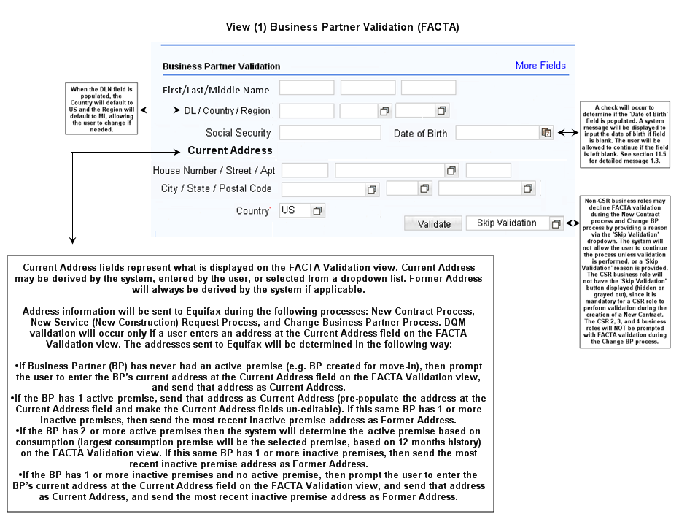

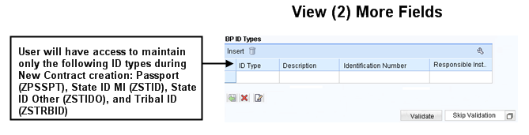

View (2) More Fields – Other forms such as State ID, Out-of-State Driver’s License, etc. will be accepted and will be available in the ‘More Fields’ view. The agent will be able to insert, modify, and delete a limited number of ID Types. If necessary the agent will be able to return to the default view by selecting the ‘Return’ icon.
Section (1) New Contract Process

- User will select New Contracts from the Contract Management Work Center sub menu:

The following checks will occur:

- A check will occur to determine if the BP has the role of a “Contract Partner” and the type of “Person”
- If No, disable FACTA View
- If Yes, continue to profile check
- CSR profile check occurs to determine if user is CSR or Non CSR
- If Yes (CSR), FACTA Validation View is displayed, however “Skip Validation” is disabled
- If No (Non CSR), FACTA Validation View is displayed with ‘Skip Validation’ enabled for user. The user has the option to ‘Validate’ or ‘Skip Validation’, (if the user skips validation, a reason must be chosen to continue).
- Data from the following fields are sent to Equifax for validation:
- Name: First, Middle, Last, Suffix
- Identification: Social Security number and/or Drivers License number, and state of issue (DLN)
- Date of Birth
- Current Address
- Former Address if applicable
- Once data is sent to Equifax, a spinning wheel will display to the user while validation runs
- Whenever FACTA Validation is ran, check for return codes: P (Pass), E (Error), F(Failed), or R (No ID)
a) If F (Failed), Continue with New Contract process, model statement will be in summary
b) If R (no ID), Continue with New Contract process, model statement will be in summary
c) If E (Error), display message: “Connectivity error occurred during validation. Please use manual process.” Return user to Identification view
d) If P (Pass), Continue with New Contract process

Calling FACTA Validation Interface:

Call Function Module: Z_DO_EQUIFAX_CHECK passing the following parameters:
IMPORTING
X_PARTNER Business Partner Number
X_VSTELLE Premise Number
X_PROCESS New Contract
X_NAME_FIRST Business Partner First Name
X_NAME_MIDDLE Business Partner Middle Name
X_NAME_LAST Business Partner Last Name
X_NAME_SUFFIX Example: Sr., Jr., MD
X_ADDR_STREET Current Address
X_ADDR_CITY City
X_ADDR_STATE State
X_ADDR_POSTCODE Zip Code
X_CONSUMER System User Id
X_DRLICENSE Drivers License Number
X_DRLICENSE_STATE State of Issue for Drivers License
X_SSN Social Security Number
X_FMR_ADDRESS Former Address
X_FMR_CITY City
X_FMR_REGI TYPE CHAR02 OPTIONAL **New
X_FMR_POSTCODE Zip Code
X_BIRTHDT Date of Birth
X_SKIP_DB X
EXPORTING
Y_RESULT_CODE Result Code

Section (2) New Service Request Process

- User will confirm BP
- User selects Order Management Work Center
- User selects ‘Create Work Order’
- User enters Keyword Search Criteria
- User selects description pertaining to New Service

The following checks will occur:

- A check will occur to determine if the BP has the role of a “Contract Partner” and the type of “Person”
- If NO, continue to Caller Info View
- If YES, FACTA Validation View is displayed, however ‘Skip Validation’ is disabled. Skip Validation is NOT an option for any business role during the New Service Request process unless the following requirements are met: There will be two instances when a non-CSR role will not go through FACTA Validation during the New Service Request process.
- If the BP already has a ZFAC/IDF contact which has been closed and a 2nd FACTA Validation occurs within 5 days of the creation date of the last change date for the IDF Contact (meaning the original IDF contact has been closed), then the non-CSR role will go automatically to the New Service Request process. If the 5 day/closed contact change does not exist, then the FACTA Validation is mandatory for the non-CSR role. The Customer Info field will be 02 (closed)
- If the BP already has a ZFAC/IDP Contact and 2nd FACTA Validation occurs within 5 days of the ZFAC/IDP Contact creation date, then the non-CSR role will go automatically to the New Service Request process. If the ZFAC/IDP Contact does not exist, then the FACTA Validation is mandatory for the non-CSR role. The Customer Info field will be 02 (closed)
- Data from the following fields are sent to Equifax for validation:
- Name: First, Middle, Last, Suffix
- Identification: Social Security number and/or Drivers License number, and state of issue (DLN)
- Date of Birth
- Current Address
- Former Address if applicable
- Once data is sent to Equifax, a spinning wheel will display to the user while validation runs
- Whenever FACTA Validation is ran, check for return codes: P (Pass), E (Error), F(Failed), or R (No ID):
a) If F (Failed), display message: "For your protection, we must validate your identification prior to completing your application for service. Further investigation is required and you will be contacted within five business days." Return user to Order Management view
b) If R (no ID), display message: “For your protection, we must validate your identification prior to placing service into your name. Since you are not providing your ID on this call, you must personally come into our office to request service and you must provide acceptable identification to an employee.” Return user to Order Management view
c) If E (Error), display message: “Connectivity error occurred during validation. Please use manual process.” Return user to Order Management view
d) If P (Pass), Caller Info view is displayed and user continues with New Service Request process

Section (3) Change Business Partner process

- User will confirm BP
- User selects Change for BP
- User makes changes to BP and selects SAVE

The following checks will occur:

- Upon saving the BP changes a check will occur to determine if changes were made to any of the fields below:
- Name
- Date of Birth
- Social Security Number
- Michigan Driver’s License
- Michigan State Issued Photo ID
- Passport
- US Military ID
- Native American Tribal ID
- If Yes, continue with BP profile check
- If No, user is returned to BP Identification view (changes made to any other fields on the BP will not require FACTA Validation)
- A check will occur to determine if the BP has the role of a “Contract Partner” and the type of “Person”
- If No, user is returned to BP identification view
- If Yes, CSR profile check occurs
- A check will occur to determine if user is a CSR
- If Yes, FACTA Validation is NOT presented to CSR business roles
- If No, FACTA Validation View is displayed to non-CSR business roles and ‘Validate and ‘Skip Validation’ is enabled.
- A check will occur to validate that SS# and/or DL# number exist before sending to Equifax
- If No, validation ends and Contact is created Class: ZFAC Action: NOID
- If Yes, Continue validation check sent to Equifax
- Data from the following fields are sent to Equifax for validation:
- Name: First, Middle, Last, Suffix
- Identification: Social Security number and/or Drivers License number, and state of issue (DLN)
- Date of Birth
- Current Address
- Former Address if applicable
- Once data is sent to Equifax, a spinning wheel will display to the user while validation runs
- Whenever FACTA Validation is ran, check for return codes: P (Pass), E (Error), F(Failed), or R (No ID)
a) If F (Failed), Continue with Change BP process
b) If R (no ID), Continue with Change BP process)
c) If E (Error), display message: “Connectivity error occurred during validation. Please use manual process.” Return user to Change BP view
d) If P (Pass), Continue with Change BP process

Input | Output
BP Data
Process Codes: M= New Contract Process/Move In, S= New Service Request Process, and U= Change Business Partner Process | Return Result code: P (Pass), E (Error), F (Failed), and R (No ID)

UI Design and Screen Flow
< Mention the WEBUI Design in the sense the mock up screens and the navigation flow between the screens etc>

Access Method or Path for Enhancement
<Select the correct execution path below by placing an ‘X’ in the checkbox next to it and completing the description that follows. Check all that apply and add any other execution methods if required by the Client. Right click on the gray box, select properties, and specify “Checked”.>
Execution: Custom Transaction Code:
Menu Path:
Standard Transaction Code:
Other: CRM 7.0 Web IC Navigation

Required Custom Tables (if known)
<Provide any information about custom tables required for this enhancement.>
Table Name: NA
Table Description: NA
M/O | Field Description | Type (text or numeric) | Maximum Field Length | Value Restrictions? | Validations?
Mention M if the field is mandatory and O if the field is optional | Enter the field description | Enter the type | Enter the max. field length | Enter any value restrictions | Mention if any validations are required or else mention NA

Error Handling Rules
<Explain what the error handling rules would be if there are any for this development. For example, if an enhancement is scheduled to be printed and it does not, what should a user do to get this corrected?>

Consumers Energy will outsource to a third party identification agency (EQUIFAX) to validate a business partners ID during the following processes for Business Partner’s with the Category Type of “Person” and Role of “MKK-Contract Partner”:

- New Contract Process
- New Service Request Process
- Change Business Partner Process

If the response from EQUIFAX is “Pass”, the CSR can continue with the process. If the response from EQUIFAX is “Fail”, the CSR will continue with the process, (with the exception of a C1 Notification) with the expectation the customer will be validated by the Red Flags group. If investigation is required, the details are immediately sent to the Fraud department’s PO Box: FACTA Red Flags (internet address: rpthd@cmsenergy.com.) Below is the step-by-step process for each activity.

FRONT OFFICE PROCESSES & CONFIGURATION

Throughout the process, new Contacts will be created in ECC. These Contacts will be configured with the specific Class & Actions:

Class | Action | Description | No Changes
ZFAC | IDP | Validation Passed | 
ZFAC | IDF | Identification Failed | 
ZFAC | DECL | Identification Check Declined | 
ZFAC | ERR | Equifax Connectivity Error | 
ZFAC | NOID | No Identification | 

For all ZFAC Contacts, the following dropdown selections are added to the Additional Info field. This field is maintained by Fraud to help track and identify the status of the Contacts.
1. FACTA - Customer Info Required
2. FACTA - No Customer Contact
3. FACTA - Failed Validation
4. FACTA – BP Changed MI Not Completed
5. FACTA - ID Theft
6. FACTA - Fraud Case
7. FACTA - Org (No Validation)
8. FACTA - Fraud Validated ID
9. FACTA - Fraud Alert
10. FACTA – Move In Reversal/Move Out Created
11. FACTA - New Resident to U.S.

Enhancement Reconciliation & Testing Requirements

Data Validation
- How will data using the enhancement be validated (e.g. compare reports, control totals etc.)?
- Is regression testing required from an SAP Data Archiving perspective?

- Data validation will require the expected test cases execution and verifying the results based on business requirements. CRM project team along with their business support teams will be responsible to ensure this enhancement works.

Testing Reconciliation
- Who will test the enhancement?

This enhancement will be tested by the teams (their security roles) who perform the New Contract process. Teams will include CRM project team, BTS support team, Call Center, BCOS, Revenue Recovery, Consumer Affairs, and Billing.

Performance Issues
- Any potential issues on performance – for archived enabled enhancements?
- Not Applicable.

Additional Information
<Enter any additional information that could be helpful in developing this enhancement.>

CRM 5.0 PP6 CCS_FO_PP6_FACTA Design Process link

Document Name: CCS_FO_PP6_FACTA Design Process

URL: https://pk3.cmsenergy.com/852575BC0041891F/(DDMAutoLaunch)?OpenAgent&DocID=F01B88A30ACA39A885257669004F3AB3

Open Items
<This includes Risks and Issues logged in Clarity and Action Items.>
Not Applicable.

Item # | Detailed Description | Proposed Solution
Insert number | Describe the item | Describe the proposed resolution

Functional Unit Test cases <Here they should list the possible test scenarios in the table below>
Test Condition Description | Input Data | Expected Results | Actual Results/Comments
New Contract Creation  CSR Business Role  BP is Contract Partner, Person |  | FACTA View is displayed, Validate is enabled, Skip Validation is disabled (grayed out)
New Contract Creation  CSR Business Role  BP has role other then Contract Partner |  | FACTA View is disabled (grayed out)
New Contract Creation  Non-CSR Business Role  BP has role other then Contract Partner |  | FACTA View is disabled (grayed out)
New Contract Creation  Non-CSR Business Role  BP is Contract Partner, Person |  | FACTA View is displayed and ‘Validation’ and ‘Skip Validation’ is enabled
New Contract Creation  Non-CSR Business Role  BP is Contract Partner, Person  User selects Skip Validation |  | The following options are displayed:  Back Office  Business Center  CES Group  Consumer Affairs  Credit Batchers  Credit Schedulers  Customer Billing  Damage Claims  Device Mgmt Inbox Team  Fraud Dept  ROC – Schedulers  Theft Dept  UA/DA – Royal Oak
New Service Request  CSR Business Role  BP is Contract Partner, Person |  | FACTA View is displayed, Validate is enabled, Skip Validation is disabled (grayed out)
New Service Request  Non-CSR Business Role  BP is Contract Partner, Person |  | FACTA View is displayed, Validate is enabled, Skip Validation is disabled (grayed out)
New Service Request  Non-CSR Business Role (CES)  BP is Contract Partner, Person  BP has ZFAC/IDF Contact which has been closed by Fraud within 5 days of this 2nd request |  | Non-CSR business role will automatically go to New Service Request process
New Service Request  CSR Business Role  BP is Contract Partner, Person  BP has ZFAC/IDF Contact which has been closed by Fraud within 5 days of this 2nd request |  | FACTA View is displayed, Validate is enabled, Skip Validation is disabled (grayed out)
Change Business Partner  CSR Business Role  BP is Contract Partner, Person |  | Upon saving changes to the BP, the user is returned to the Identification View, since FACTA Validation does NOT occur for the CSR Business Role during the Change Business Partner Process
Change Business Partner  Non-CSR Business Role  BP is Contract Partner, Person  Change is made to BP phone number and SAVED |  | FACTA View is not displayed since change was not made to one of the following fields:  Date of Birth  Social Security Number  Michigan Driver’s License  Michigan State Issued Photo ID  Passport  US Military ID  Native American Tribal ID
Change Business Partner  Non-CSR Business Role  BP is Contract Partner, Person  Change is made to BP’s Date of Birth |  | FACTA View is displayed with ‘Validation’ and ‘Skip Validation’ buttons enabled
Change Business Partner  Non-CSR Business Role  BP role is Org  Change is made business id |  | FACTA View will not display, since BP does not have role of Contract Partner, type of Person
New Contract Creation  CSR Business Role  Existing BP is Contract Partner, Person |  | FACTA View is displayed and Previous Address section is populated with BP’s most recent premise address
New Contract Creation  CSR Business Role  New BP is Contract Partner Person |  | FACTA View is displayed and Previous Address section is blank
New Service Request  Non-CSR Business Role,  Existing BP is Contract Partner, Person |  | FACTA View is displayed and Previous Address section is populated with BP’s most recent premise address
New Service Request  Non-CSR Business Role,  New BP is Contract Partner, Person |  | FACTA View is displayed and Previous Address section is blank
Change Business Partner  Non-CSR Business Role,  BP had service with us last year |  | FACTA View is displayed and Previous Address section is populated with BP’s most recent premise address
Change Business Partner  Non-CSR Business Role,  BP has never had active Contract with CE |  | FACTA View is displayed and Previous Address section is populated with BP’s default address
New Contract  CSR Business Role,  BP moving in has State ID |  | State ID is saved to BP

